Charley Kirk
Dr. Rhodes
Data Mining
17 October 2024
Recent Graduates Draft for Week 7
Project Description
I am going to stick with the name Recent Graduates for the project. It was suggested that we pick something from our major, but my major is Data Science so I just tried to pick a subject that was somewhat interesting to me. This dataset contains information about recent graduates, including their major, their employment, their gender, and their earnings. Each observation in the dataset is of a different major. This dataset was last updated 7 years ago. The data was used in a piece by FiveThirtyEight on “the earnings of college majors.” The csv I pulled from is for a table with 21 attributes so I picked 15 of them to use for this project. I have given variable descriptions for these 15 attributes in the Data Sources section. From this dataset I expect to find that graduates who have jobs that require college degrees are financially better off than graduates who have jobs that do not require a college degree.
If I wanted to give a presentation on this data, the expected audience would probably be recent graduates or people graduating soon, as I think they would be the ones most interested in what to expect financially post-graduation. It is also possible that people who have not gone to college could use this data to help inform their decision on whether or not to pursue a college degree, as they can compare, among other things, the number of people who have jobs requiring a college degree to the number of people with jobs that do not have a college degree and the number of people in a given major who have found employment. This data is interesting to me personally because I have been job searching as a graduate for some time now with limited success.
Data Sources
I found this dataset on data.world after clicking on their “education” data topic; from the list of datasets I picked one called “College Majors” and from a group of csvs I picked out the one called “recent-grads.csv.”
I used the glimpse function in RStudio to create snippets of the table. Because of large value lengths some attributes like Major display less than five values, but I provided a snippet of the head of the data, a snippet of the tail of the data and a random sample of the data to help give a sense of what the dataset looks like, so I figured it wasn’t too important.
recsub%>%
head()%>%
glimpse()
## Rows: 6
## Columns: 15
## $ Rank <dbl> 1, 2, 3, 4, 5, 6
## $ Major <chr> "PETROLEUM ENGINEERING", "MINING AND MINERAL ENGI…
## $ Major_category <chr> "Engineering", "Engineering", "Engineering", "Eng…
## $ Total <dbl> 2339, 756, 856, 1258, 32260, 2573
## $ Sample_size <dbl> 36, 7, 3, 16, 289, 17
## $ Men <dbl> 2057, 679, 725, 1123, 21239, 2200
## $ Women <dbl> 282, 77, 131, 135, 11021, 373
## $ ShareWomen <dbl> 0.1205643, 0.1018519, 0.1530374, 0.1073132, 0.341…
## $ Full_time_year_round <dbl> 1207, 388, 340, 692, 16697, 1449
## $ Median <dbl> 110000, 75000, 73000, 70000, 65000, 65000
## $ P25th <dbl> 95000, 55000, 50000, 43000, 50000, 50000
## $ P75th <dbl> 125000, 90000, 105000, 80000, 75000, 102000
## $ College_jobs <dbl> 1534, 350, 456, 529, 18314, 1142
## $ Non_college_jobs <dbl> 364, 257, 176, 102, 4440, 657
## $ Low_wage_jobs <dbl> 193, 50, 0, 0, 972, 244
recsub%>%
tail()%>%
glimpse()
## Rows: 6
## Columns: 15
## $ Rank <dbl> 168, 169, 170, 171, 172, 173
## $ Major <chr> "COMPOSITION AND RHETORIC", "ZOOLOGY", "EDUCATION…
## $ Major_category <chr> "Humanities & Liberal Arts", "Biology & Life Scie…
## $ Total <dbl> 18953, 8409, 2854, 2838, 4626, 1098
## $ Sample_size <dbl> 151, 47, 7, 13, 21, 2
## $ Men <dbl> 14440, 3050, 522, 568, 931, 134
## $ Women <dbl> 28809, 5359, 2332, 2270, 3695, 964
## $ ShareWomen <dbl> 0.6661194, 0.6372934, 0.8170988, 0.7998591, 0.798…
## $ Full_time_year_round <dbl> 7832, 3602, 1211, 1293, 2738, 410
## $ Median <dbl> 27000, 26000, 25000, 25000, 23400, 22000
## $ P25th <dbl> 20000, 20000, 24000, 25000, 19200, 20000
## $ P75th <dbl> 35000, 39000, 34000, 40000, 26000, 22000
## $ College_jobs <dbl> 4855, 2771, 1488, 986, 2403, 288
## $ Non_college_jobs <dbl> 8100, 2947, 615, 870, 1245, 338
## $ Low_wage_jobs <dbl> 3466, 743, 82, 622, 308, 192
recsub%>%
sample_n(6, TRUE)%>%
glimpse()
## Rows: 6
## Columns: 15
## $ Rank <dbl> 12, 51, 119, 167, 74, 147
## $ Major <chr> "AEROSPACE ENGINEERING", "ENGINEERING AND INDUSTR…
## $ Major_category <chr> "Engineering", "Engineering", "Health", "Arts", "…
## $ Total <dbl> 15058, 2906, 19735, 43249, 124, 60633
## $ Sample_size <dbl> 147, 29, 130, 357, 4, 419
## $ Men <dbl> 65511, 2400, 8575, 7022, 1756, 15670
## $ Women <dbl> 16016, 506, 16075, 11931, 1323, 12543
## $ ShareWomen <dbl> 0.1964503, 0.1741225, 0.6521298, 0.6295046, 0.429…
## $ Full_time_year_round <dbl> 8790, 1358, 7460, 16891, 111, 21425
## $ Median <dbl> 60000, 44000, 34000, 27000, 40000, 31000
## $ P25th <dbl> 42000, 30000, 21000, 19200, 40000, 22300
## $ P75th <dbl> 70000, 50000, 45000, 35000, 40000, 42000
## $ College_jobs <dbl> 8184, 482, 5225, 6994, 0, 13752
## $ Non_college_jobs <dbl> 2425, 844, 7385, 25313, 0, 28786
## $ Low_wage_jobs <dbl> 372, 245, 1854, 11068, 0, 9286

Name | Type | Range | Description
Rank | Ordinal, discrete. |  | An assigned ranking based on the median earnings of graduates who work full-time and year-round.
Major | Nominal, categorical |  | The name of the major, e.g. Petroleum Engineering.
Major_category | Nominal, categorical |  | Gives a broader field the major falls into, e.g. “Engineering” instead of “Petroleum Engineering.”
Total | Ratio, discrete | Non-negative. | The number of graduates with the major.
Sample_size | Ratio, discrete | Non-negative. | The number of graduates who work full-time and year-round used to compute Median, P25th and P75th.
Men | Ratio, discrete | Non-negative. | The number of men who graduated with the major.
Women | Ratio, discrete | Non-negative. | The number of women who graduated with the major.
ShareWomen | Ratio, continuous | 0 to 1. | The decimal proportion of graduates in the major who are women.
Full_time_year_round | Ratio, discrete | Non-negative. | The number of graduates in the major who work at least 35 hours a week and at least 50 weeks a year based on “WKW” and “WKHP.”
Median | Ratio, discrete | Non-negative. | The median annual income of graduates in the major who work full-time and year-round.
P25th | Ratio | Non-negative. | Same as above but it’s the 25th percentile not the 50th percentile.
P75th | Ratio | Non-negative. | Same again but it’s the 75th percentile.
College_jobs | Ratio | Non-negative. | The number of graduates in the major who have a job that requires a college degree.
Non_college_jobs | Ratio | Non-negative. | The number of graduates in the major who have a job that does not require a college degree.
Low_wage_jobs | Ratio | Non-negative. | The number of graduates in the major who have a “low-wage service job.”

URLs

Note: when you use the Census Bureau link for the page where the data was originally pulled a 404 message pops up. But below that message you should see a hyperlink for the American Community Survey (ACS) page which I believe is the survey that was used to collect the data. I also included a link for the College Majors dataset on data.world, and a github link for FiveThirtyEight that was provided on that data.world page.

https://data.world/fivethirtyeight/college-majors
https://github.com/fivethirtyeight/data
http://www.census.gov/acs/www/data_documentation/pums_data/
Data Preprocessing

The dataset I found was already relatively clean, and I have not yet found a need to modify the column values or merge the dataset with another. I have deleted some columns from the dataset that I will not be using for the project however. For the version of the dataset I have in Python, I did this by only listing 15 out of the original 21 columns in the usecols argument in the read_csv() function. Here is a copy of the code I used:

import pandas as pd

rdata = pd.read_csv('~/Dropbox/Charley/Juniata/Data Science Masters/Data Mining/recent-grads.csv', usecols=[4, 5, 6, 7, 8, 12, 15, 16, 17, 18, 19, 20])

For the version of the dataset I have in RStudio I used the select() function to isolate the columns:
recsub<-recent_grads%>%
select(Rank, Major, Major_category, Total, Sample_size, Men, Women, ShareWomen, Full_time_year_round, Median, P25th, P75th, College_jobs, Non_college_jobs, Low_wage_jobs)

There is a chance I may change the existing column names to follow a different formatting convention but for now they remain as they are. I may eventually create a new csv with the unnecessary columns removed and I may use either Python or RStudio to do that since I know how to write out to a csv file in both of them.
While I haven’t modified existing columns I did create some new ones for data mining purposes, which I will get into in the next section.
Data Exploration/Visualization

The following two graphs were made using RStudio.
recent_grads%>%
pivot_longer(c(Men, Women), names_to = "Gender", values_to = "G_Total")%>%
ggplot()+
geom_col(aes(Major_category, G_Total, fill=Gender), position="dodge")+
coord_flip()
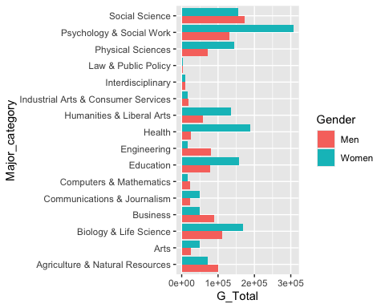
This is a side-by-side bar chart. The 16 major categories are shown on one axis and the other axis shows the number of graduates in that major category with the bars broken up by gender. Blue bars show the number of women in the major category and red bars show the number of men in the major category. From this graph we can observe that Engineering is much more popular with men than women, while Education is more popular with women than men. The Law and Public Policy category is pretty unpopular in general while Social Science seems pretty popular for both men and women.
recent_grads%>%
filter(Median>=60000)%>%
mutate(Major=fct_reorder(Major, Median))%>%
ggplot()+
geom_col(aes(Major, Total))+
coord_flip()
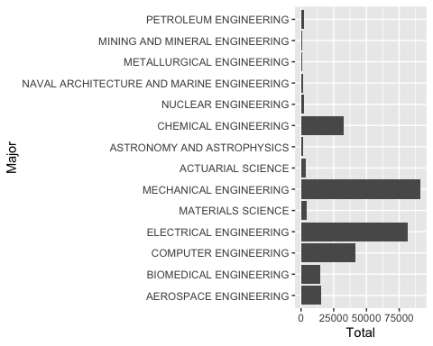
This graph was inspired by a table in the FiveThirtyEight piece that made use of the same data. Although I did not include Median in this graph explicitly, I did order the levels of Major in decreasing order of Median so that the majors with the highest median earnings appeared at the top and the majors with the lowest median earnings appeared at the bottom. That said the order is still slightly arbitrary because some majors have the same value for Median; for example Nuclear Engineering and Chemical Engineering have the same value for Median and so Chemical Engineering could be written before Nuclear Engineering and vice versa. The graph shows that even though majors like Petroleum Engineering, Mining and Mineral Engineering and Metallurgical Engineering all have high median earnings, there are majors with lower median earnings that are vastly more popular like Mechanical Engineering and Electrical Engineering.
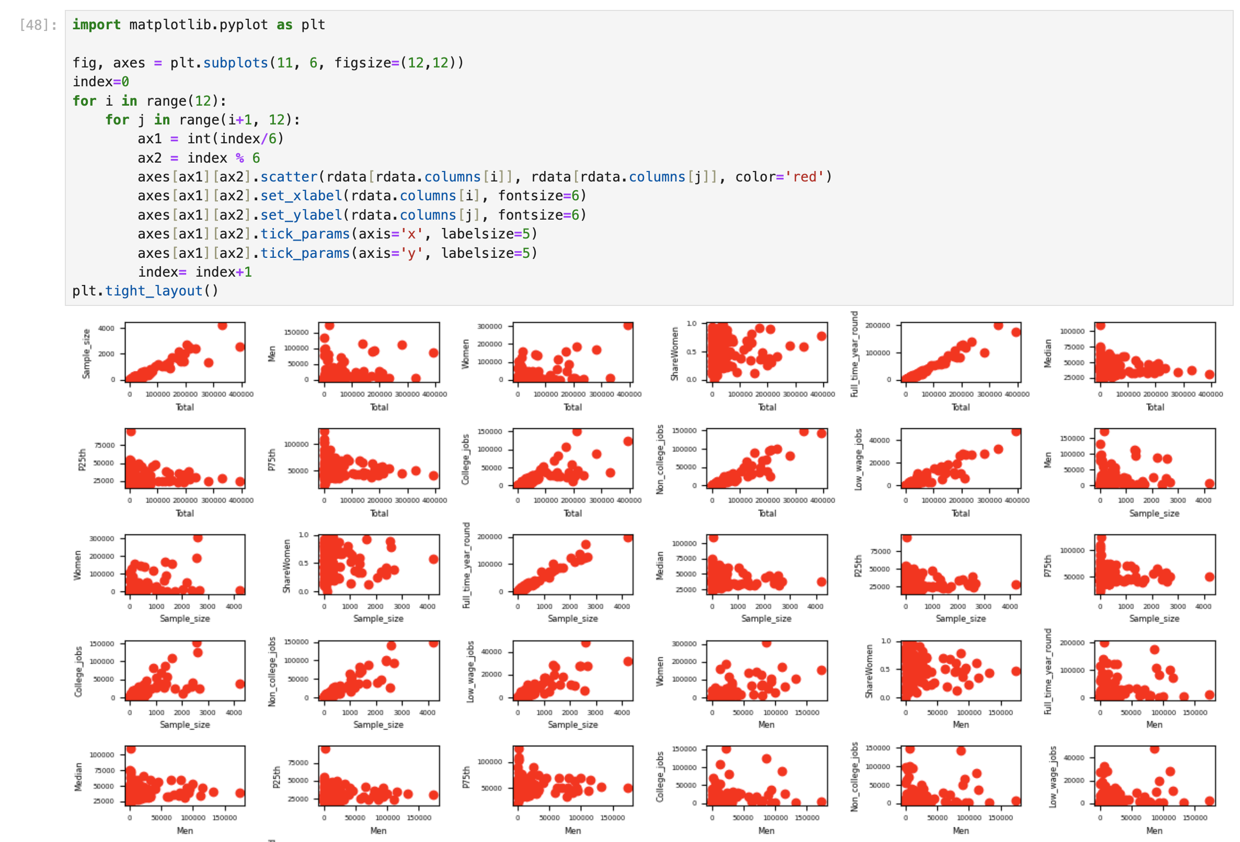
The following scatterplot matrix was made in Python.

The plot in the bottom right corner does suggest a strong positive correlation between the number of Non_college_jobs and the number of Low_wage_jobs, which may support the hypothesis that graduates who have jobs that require college degrees are financially better off than graduates who have jobs that do not require a college degree. On the other hand the plot of College_jobs and Median 2 spaces above does not show an obvious correlation.
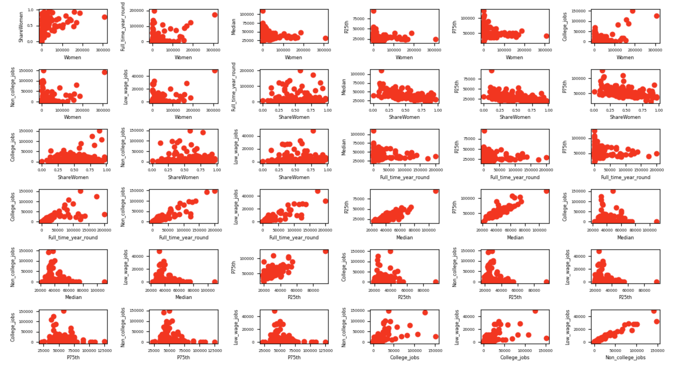
I started analyzing my data using the Apriori algorithm in Weka. Since the algorithm on Weka wouldn’t work with quantitative variables I used RStudio to perform some binning, and wrote the resulting dataframe to csv.
miningset<-recsub%>%
mutate(col_rate = (College_jobs/Total), col_bin=cut(col_rate, breaks=10), median_bin=cut(Median, breaks=10), low_rate=(Low_wage_jobs/Total), low_bin=cut(low_rate, breaks=10))%>%
select(Major_category, col_bin, median_bin, low_bin)
write.csv(miningset,"~/Dropbox/Charley/Juniata/Data Science Masters/Data Mining/miningset.csv")

I loaded the csv in Weka and generated this ruleset with metricType set to Lift and minMetric set to 1.1:
1. median_bin=(3.08e+04,3.96e+04] 75 ==> low_bin=(0.12,0.15] 19 conf:(0.25) < lift:(1.99)> lev:(0.05) [9] conv:(1.15)
2. low_bin=(0.12,0.15] 22 ==> median_bin=(3.08e+04,3.96e+04] 19 conf:(0.86) < lift:(1.99)> lev:(0.05) [9] conv:(3.12)
3. median_bin=(3.08e+04,3.96e+04] 75 ==> low_bin=(0.0903,0.12] 24 conf:(0.32) < lift:(1.42)> lev:(0.04) [7] conv:(1.12)
4. low_bin=(0.0903,0.12] 39 ==> median_bin=(3.08e+04,3.96e+04] 24 conf:(0.62) < lift:(1.42)> lev:(0.04) [7] conv:(1.38)
5. col_bin=(0.225,0.301] 36 ==> median_bin=(3.08e+04,3.96e+04] 21 conf:(0.58) < lift:(1.35)> lev:(0.03) [5] conv:(1.27)
6. median_bin=(3.08e+04,3.96e+04] 75 ==> col_bin=(0.225,0.301] 21 conf:(0.28) < lift:(1.35)> lev:(0.03) [5] conv:(1.08)

I also looked at bar plots of the bin columns I created to try and get a sense of what the support counts might be like for itemsets featuring specific bins and also to get a sense of the distributions of these quantitative variables. While using geom_histogram() on the original variables also probably would have worked, this was slightly more convenient as the labels of the bins match up with their labels in Weka.
miningset%>%
ggplot()+
geom_bar(aes(median_bin))+
coord_flip()
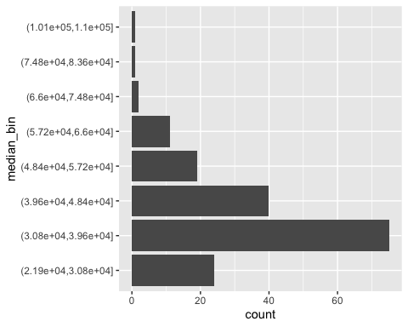
The graph of median_bin above is right-skewed which could be reflective of income inequality. It might look a bit similar to the graph of low_bin below.
miningset%>%
ggplot()+
geom_bar(aes(low_bin))+
coord_flip()
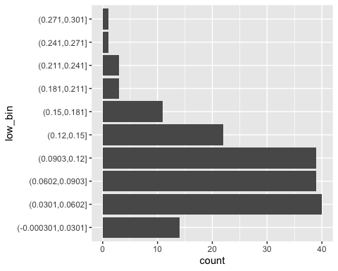
miningset%>%
ggplot()+
geom_bar(aes(col_bin))+
coord_flip()
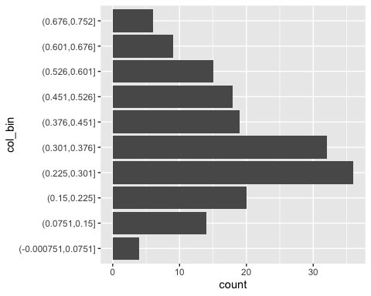
col_bin seems to have a more symmetric distribution, but it’s tricky to say whether that’s a good thing or not without finding a pattern between College_jobs and the income variables.
Preliminary Data Mining Results

My data mining results from Weka showed a rule with a confidence value of 0.86 and a lift value of 1.99:
low_bin=(0.12,0.15] ==> median_bin=(3.08e+04,3.96e+04].
The practical interpretation of this is a bit tricky. When we consider the median_bin and low_bin histograms from the previous section, (3.08e+04,3.96e+04] is the second lowest of the median income bins in the histogram which we might expect to be associated with people in low wage jobs, and that makes it a little strange that the strongest pattern would be found with (0.12,0.15] when there a low wage bins that are above it on the low_bin histogram. I may tweak the parameters of the Apriori algorithm to see what other results I can obtain.
I may also show some results from the J48 decision tree algorithm in a future submission as well.

